**Social Media Platform Testing**

**Test Plan**

**Overview:**

**Project Name**: Social Media Platform Testing  
**Objective**: Validate the core functionalities like user registration, posting content, and interactions (likes, comments, shares).  
**Scope**:

* User registration and login
* Posting and sharing content
* Notifications and real-time updates

**Test Environment:**

* Browsers: Chrome, Safari, Edge
* Devices: Desktop, Mobile
* Tools: JIRA, Zephyr, BrowserStack

**Test Deliverables:**

* Test Cases
* Test Execution Report
* Defect Log

**Risks:**

* High dependency on third-party APIs for notifications.
* Limited testing for simultaneous real-time interactions.

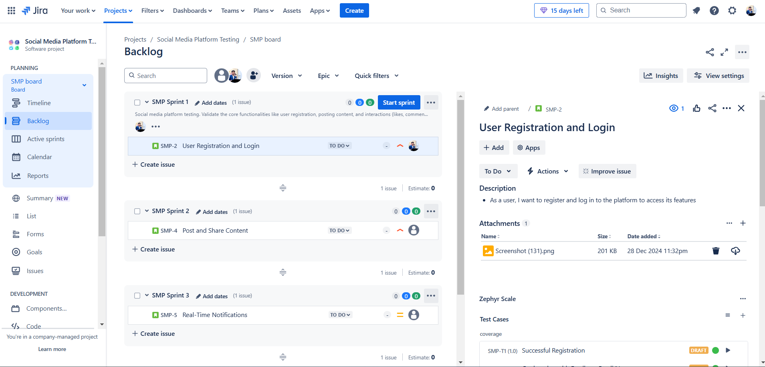

SMP-2 **User Registration and Login**

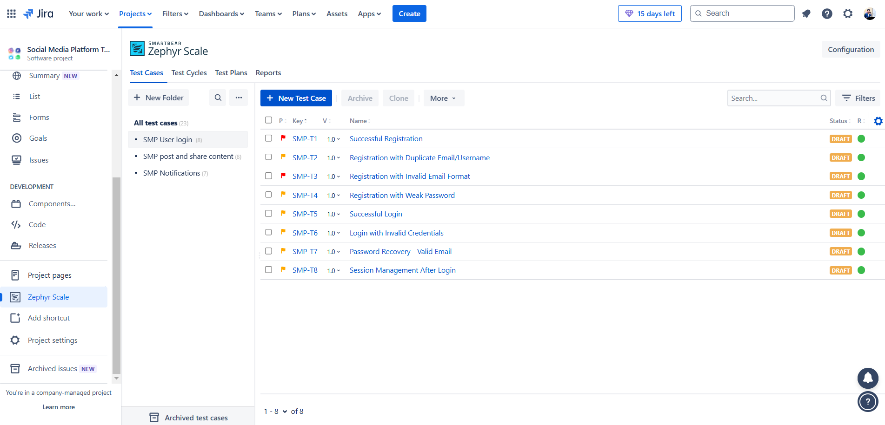

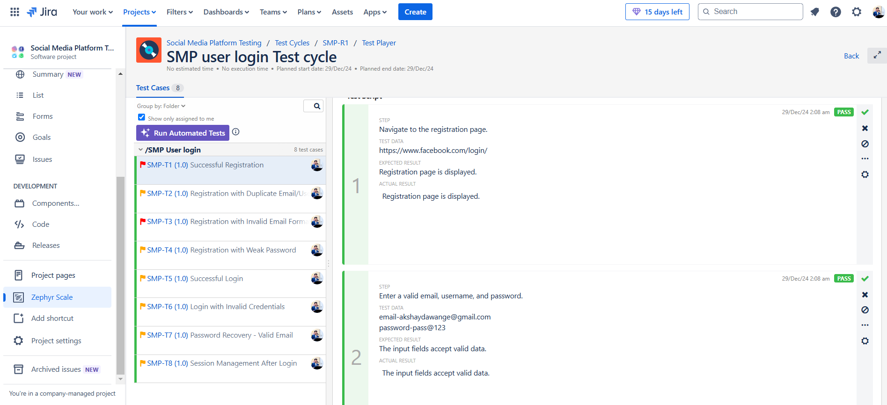

SMP-4 **Post and Share Content**



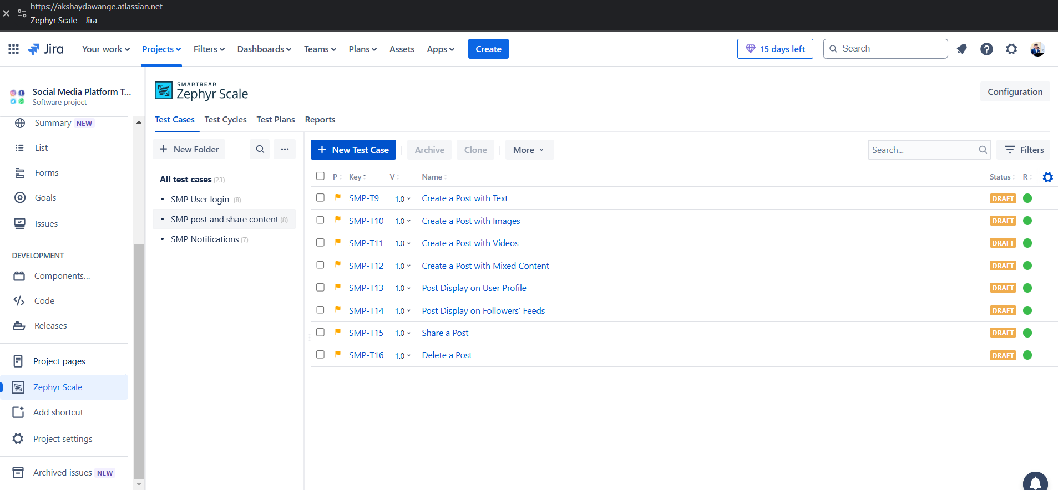

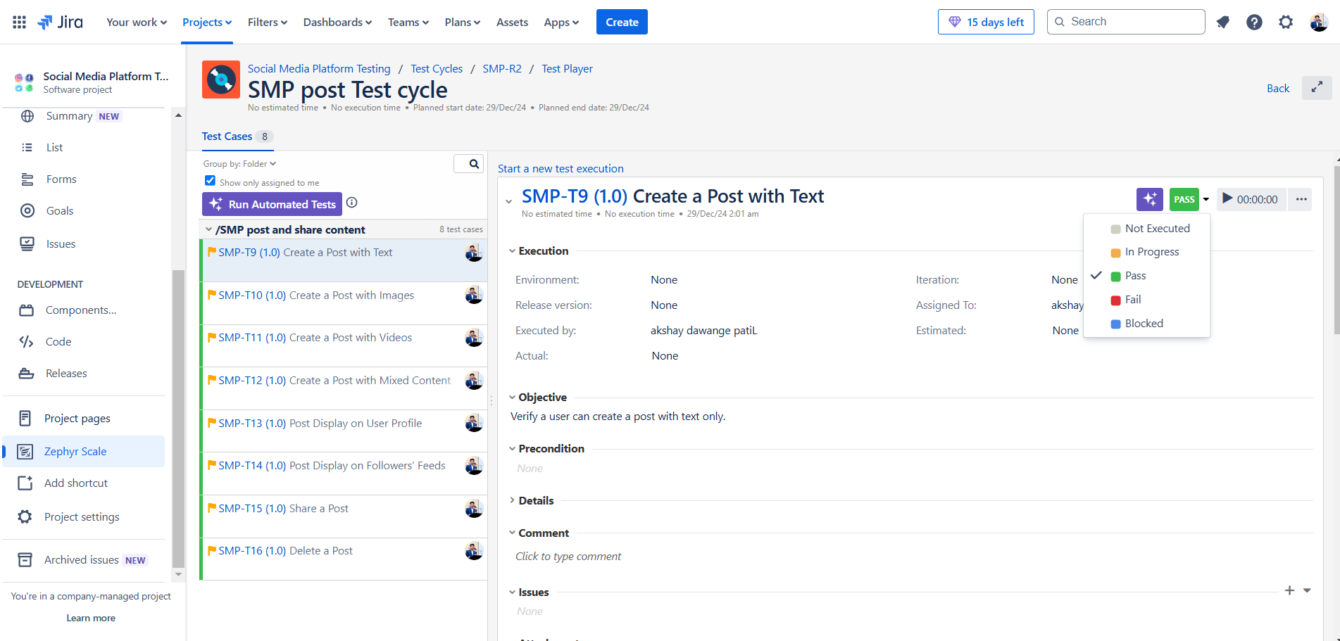

SMP-5 Real-Time Notifications

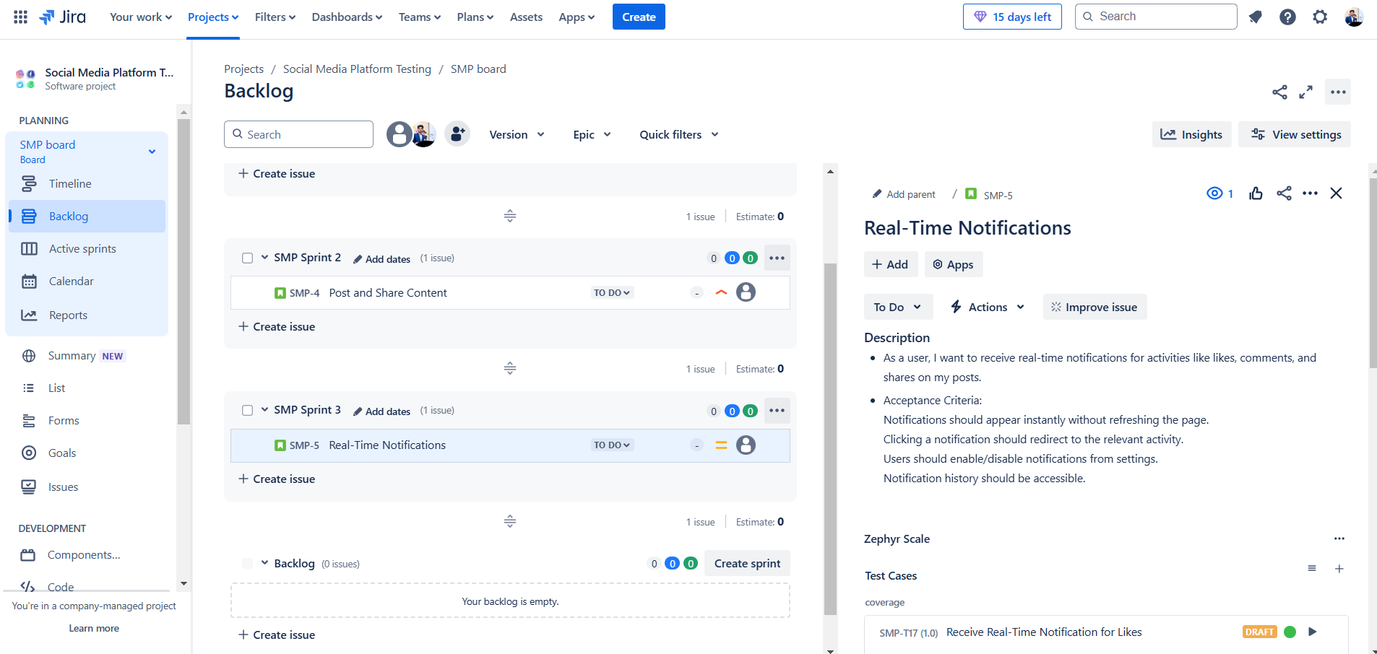

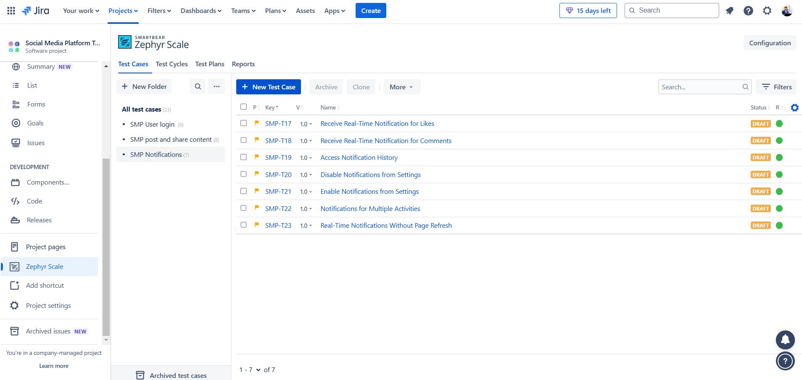

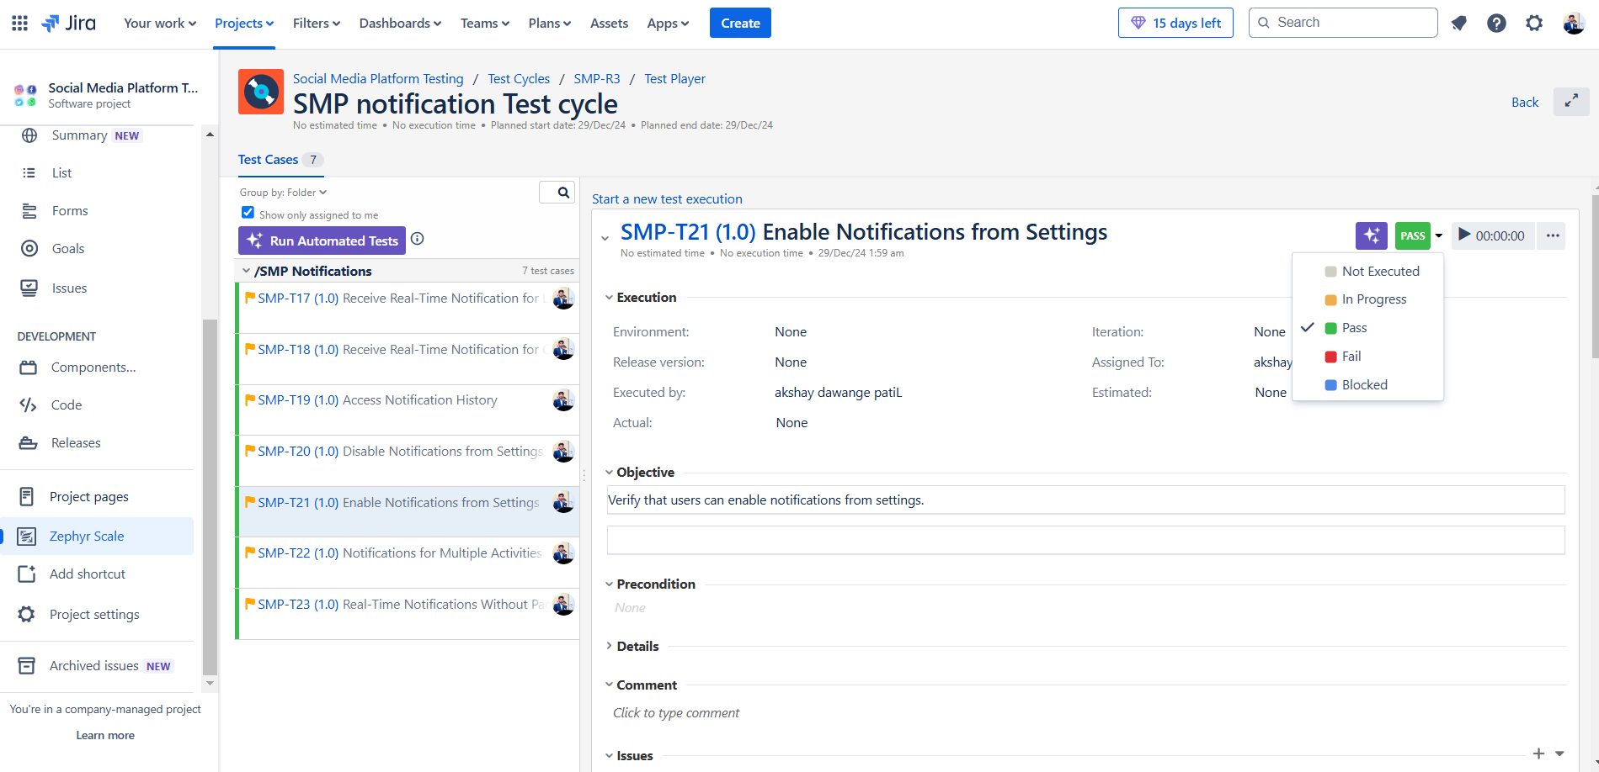

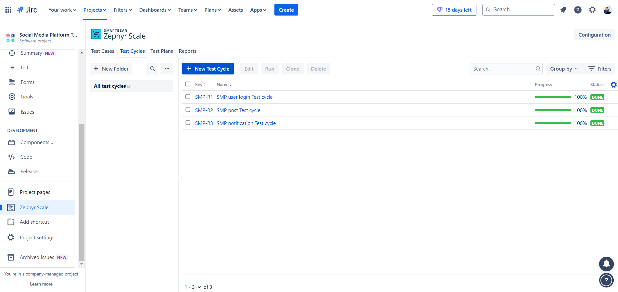

**Requirement Traceability Matrix (RTM)**

| **Requirement ID** | **Requirement Description** | **Test Case ID** | **Test Status** |
| --- | --- | --- | --- |
| R1 | User registration and login | TC1 | Passed |
| R2 | Create and post content | TC2 | Passed |
| R3 | Like and comment on posts | TC3 | Passed |
| R4 | Notifications for user interactions | TC4 | Passed |

**Test Cases**

**Functional Test Cases**

| **Test Case ID** | **Test Case Description** | **Steps** | **Expected Result** | **Status** |
| --- | --- | --- | --- | --- |
| TC1 | User registration and login | 1. Open website 2. Enter registration details 3. Confirm email 4. Login with credentials | User is registered and logged in successfully | Passed |
| TC2 | Create and post content | 1. Navigate to Create Post 2. Enter text and upload image 3. Click Post | Post is successfully created and visible on the timeline | Passed |
| TC3 | Like and comment on posts | 1. View a post 2. Click Like 3. Add a comment and submit | Like and comment are successfully added | Passed |
| TC4 | Notifications for user interactions | 1. Like or comment on another user's post 2. Check notifications | Notification is received by the user | Passed |

**Security Testing Checklist**

| **Area** | **Security Test** | **Result** |
| --- | --- | --- |
| Authentication | Test login with invalid credentials | Passed |
| Authorization | Test restricted pages without login | Passed |
| Data Protection | Verify sensitive data is encrypted (e.g., passwords) | Passed |
| Session Management | Test session timeout and cookie expiration | Passed |